No7



Demonstrate self-directed learning abilities to complete the practicum
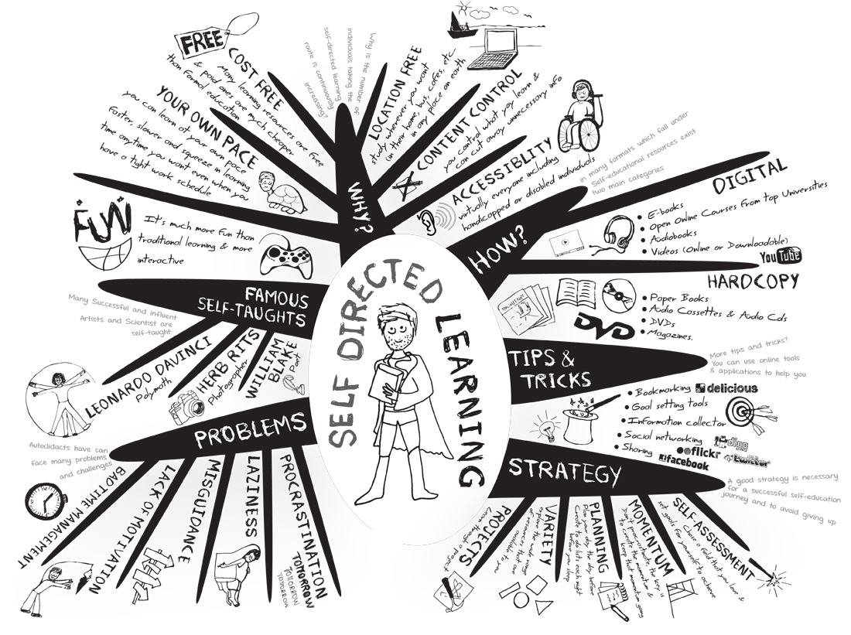



Self-Directed Learning: Definition & Strategies.

Self-directed learning is a type of instructional strategy where students take charge of their learning process. This lesson will discuss components, benefits, and teaching strategies of self-directed learning.

Its broadest meaning, self-directed learning describes a process in which individuals take the initiative, with or without the help of others, in diagnosing their learning needs, formulating learning goals, identifying human and material resources for learning, choosing and implementing appropriate learning.

30 Universal Strategies for Learning
As teachers, we’re all trying to better understand how people learn–not now they’re taught in terms of teaching strategies, but more so learning strategies–only not really strategies. Learning actions, or cognitive actions.
Self-directed and social learning will undoubtedly be at the core of any sort of future learning–both near and far future. But to improve learning in both self-directed and teacher-centered learning environments, it can be illuminating to look past the activities, projects, and courses to try to see what sort of brain-level actions learners are performing. Like push-ups, wind sprints, and weight training are physical actions that help train an athlete’s body, what kind of cognitive actions train a learner’s mind?
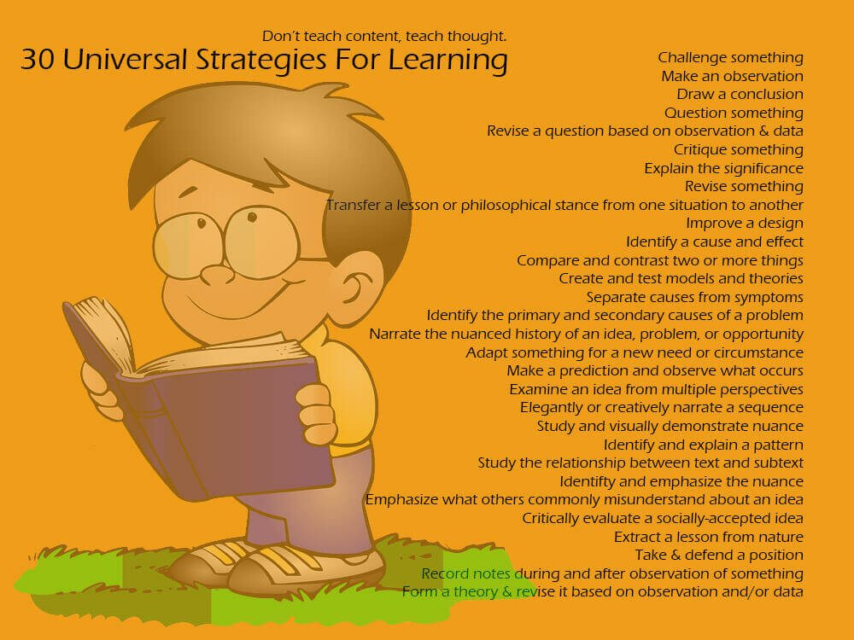
Bloom’s taxonomy–especially the annotated “Bloom’s Wheel”–helpfully offers power verbs that drive the planning of learning activities, but I wanted to be even more specific. The goal here is to create a self-directed learning model that supports 21st century learners in finding, analyzing, improving, repackaging and sharing data in pursuit of self-knowledge. But pushed further, what are those specific strategies that work universally?

15 Ways of the Successful Self-Directed Learner

The “why” of self-directed learning is survival—your own survival as an individual, and also the survival of the human race. Clearly, we are not talking here about something that would be nice or desirable….We are talking about a basic human competence—the ability to learn on one’s own—that has suddenly become a prerequisite for living in this new world. – Malcolm Knowles, 1975
While lifelong learning and self-directed learning are not equivalent, they overlap substantially. I think the following points apply equally to both. The successful lifelong learner is someone who:
1. Takes initiative
This first one is core to the entire concept of “self-directed.” The successful self-directed learner does not wait for someone else to say “you must learn this.”
2. Is comfortable with independence
Self-directed learners do not always act autonomously or independently. Indeed, increasingly they must cultivate their networks to learn effectively. Nonetheless, successful self-directed learners know how to be self-reliant.
3. Is persistent
Learning takes time, it takes repetition, it takes practice. Successful self-directed learners stick to it.
4. Accepts responsibility
The successful self-directed learner embraces responsibility for doing the work of learning and doing it well
5. Views problems as challenges, not obstacles
The successful self-directed learner embraces a growth mindset and is not easily thwarted when the going gets tough.
6. Is capable of self-discipline
Even when learning is enjoyable (which, for the successful self-directed learner, it usually is), it often requires discipline. The self-directed learner knows (or learns!) how to develop and maintain discipline.
7. Has a high degree of curiosity
Successful self-directed learners have a high propensity for asking why – and lots of other questions.

8. Has a strong desire to learn or change
The successful self-directed learner is intrinsically motivated. She has a will to learn and sees learning as a positive path forward.
9. Is self-confident
Successful self-directed learners have a solid sense of “self-efficacy” – the belief that one is capable of performing in a certain manner to attain certain goals
10. Is able to use basic study skills
As I have said here before, skills like taking notes effectively are useful for a lifetime. The self-directed learner knows this.
11. Organizes his or her time
While self-directed learning does not require the obsession with productivity that seems to be everywhere on the Interweb, the successful self-directed learner nonetheless knows how to find and manage time effectively to allow for learning.
12. Sets an appropriate pace for learning
The successful self-directed learner recognizes that learning is as much (if not more) about the process than the outcome and doesn’t try to do too much too fast.
13. Develops a plan for completing work
Setting a plan is part of setting the pace and ultimately reaching the destination. The successful self-directed learner recognizes this.
14. Has a tendency to be goal-oriented
While not all self-directed learners consciously set goals, they nonetheless tend to have an end in mind when they start down the learning path.
15. Enjoys learning
The proverbial bottom line: the successful self-directed learner simply likes to learn.

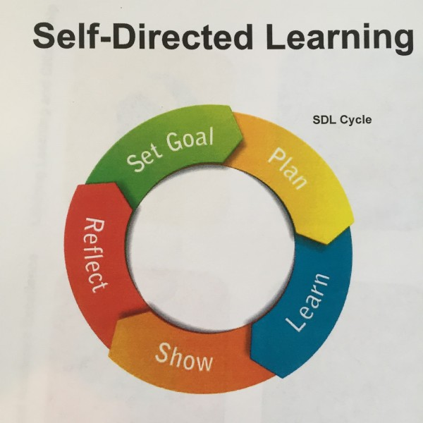
Self-Directed Learning: A Four-Step Process

Step 1: Assess readiness to learn
Students need various skills and attitudes towards learning for successful independent study. This step involves students conducting a self-evaluation of their current situation, study habits, family situation, and support network both at school and at home and also involves evaluating past experiences with independent learning. For a detailed Learning Skills Assessment Tool, read our Learn Teaching Tip. Signs of readiness for self-directed learning include being autonomous, organized, self-disciplined, able to communicate effectively, and able to accept constructive feedback and engage in self-evaluation and self-reflection.

Step 2: Set learning goals
Communication of learning goals between a student and the advising instructor is critical. We've developed a set of questions for students to consider as they map out their learning goals: our Unit Planning Decision Guide). Also critical in developing a clear understanding of learning goals between students and instructors are learning contracts. Learning contracts generally include:
- Goals for the unit of study
- Structure and sequence of activities
- Timeline for completion of activities
- Details about resource materials for each goal
- Details about grading procedures
- Feedback and evaluation as each goal is completed
- Meeting plan with the advising instructor
- Agreement of unit policies, such as a policy on late assignments
Once created, contracts should be assessed by the advising faculty member and questions about feasibility should be raised (e.g., what could go wrong? Is there too much or too little work? Is the timeline and evaluation reasonable?).

Step 3: Engage in the learning process
Students need to understand themselves as learners in order to understand their needs as self-directed learning students referring students to our resource on learning preferences may be helpful. Students should also consider answering the following questions:
- What are my needs re: instructional methods?
- Who was my favorite teacher? Why?
- What did they do that was different from other teachers? Students should reflect on these questions throughout their program and substitute “teacher” with “advising instructor”
Students also need to understand their approach to studying:
- A deep approach to studying involves transformation and is ideal for self-directed learning. This approach is about understanding ideas for yourself, applying knowledge to new situations and using novel examples to explain a concept, and learning more than is required for unit completion.
- A surface approach involves reproduction: coping with unit requirements, learning only what is required to complete a unit in good standing, and tending to regurgitate examples and explanations used in readings.
- A strategic approach involves organization: achieving the highest possible grades, learning what is required to pass exams, memorizing facts, and spending time practicing from past exams.
Earlier academic work may have encouraged a surface or strategic approach to studying. These approaches will not be sufficient (or even appropriate) for successful independent study. Independent study requires a deep approach to studying, in which students must understand ideas and be able to apply knowledge to new situations. Students need to generate their own connections and be their own motivators.

Step 4: Evaluate learning
For students to be successful in self-directed learning, they must be able to engage in self-reflection and self-evaluation of their learning goals and progress in a unit of study. To support this self-evaluation process, they should:
- regularly consult with the advising instructor,
- seek feedback, and
- engage in reflection of their achievements, which involves asking:
  - How do I know I’ve learned?
  - Am I flexible in adapting and applying knowledge?
  - Do I have confidence in explaining material?
  - When do I know I’ve learned enough?
  - When is it time for self-reflection and when is it time for consultation with the advising faculty member?

Responsibilities in the four-step process
Successful independent study requires certain responsibilities or roles of both students and advising faculty members. The following is a brief list of the more important roles. It is useful for both students and advising faculty members to periodically review this list and communicate as to whether each feels the other is fulfilling their share of the responsibility.

Students’ roles
- Self-assess your readiness to learn
- Define your learning goals and develop a learning contract
- Monitor your learning process
- Take initiative for all stages of the learning process — be self-motivated
- Re-evaluate and alter goals as required during your unit of study
- Consult with your advising instructor as required

Advising instructors’ roles
- Build a co-operative learning environment
- Help to motivate and direct the students’ learning experience
- Facilitate students’ initiatives for learning
- Be available for consultations as appropriate during the learning process
- Serve as an advisor rather than a formal instructor
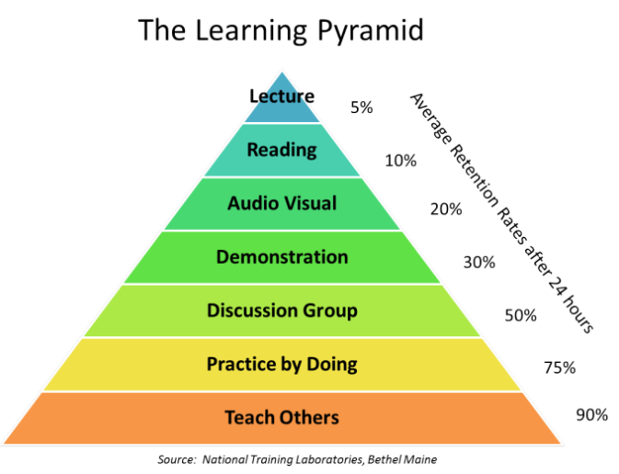
Learning Methods - Learning Styles
Enhanced Learning using Technology
Computer Supported Collaborative Learning takes
place via social interaction using a computer or through
the Internet.

Teaching Machine
Adaptive Learning
is an educational method which uses computers as interactive teaching devices, and to orchestrate the allocation of human and mediated resources according to the unique needs of each learner.
Interactive Learning
is a pedagogical approach that incorporates social networking and urban computing into course design and delivery. Interactive Learning has evolved out of the hyper-growth in the use of digital technology and virtual communication, particularly by students. Interactive is capable of acting on or influencing each other.

Reflective writing and critical incidents


Reflection on practice is an important aspect of your ongoing professional learning. In your course, this may take the form of a critical incident report. However, the focus is less on the event or incident or experience in itself – what is important is your reaction to it, and how it has informed your thinking and your learning.
Assessment tends to focus on how successfully you have demonstrated a capacity to analyse and reflect on events in order to learn from them. Also relevant to assessment is how much you are able to relate your current theoretical learning (for example, about the doctor-patient relationship, or about what constitutes effective communication) to a real life situation.
The section on characteristics of reflective writing covers language features like:
- tenses
- speculative and hypothetical writing
- the language of self-reflection vs criticism.

Reflective writing
Reflective writing is writing which involves '… consideration of the larger context, the meaning, and the implications of an experience or action' (Branch & Paranjape, 2002, p. 1185). In medical and health science courses you are required to produce reflective writing in order to learn from
educational and practical experiences, and to develop the habit of critical reflection as a future health professional.
Reflective writing may be based on:
- description and analysis of a learning experience within the course:
  - a community placement
  - a clinical placement
  - a rural placement
- description and analysis of a past experience
- review of your learning or course to that point
- description and analysis of a critical incident.
Role of reflection
Students sometimes view reflective writing as an annoying interruption to the serious business of developing content knowledge in their subject area. However, there are sound reasons why reflective writing is included in student assessment.
"Reflection is indicative of deep learning, and where teaching and learning activities such as reflection are missing… only surface learning can result." Biggs 1999 in King 2002
Reflective writing tasks are given to students to help students learn through reflection, precisely because of the established link between reflection and deeper learning. As well as facilitating learning and monitoring learning, the intention is to produce graduates who have acquired the habit of reflection as a means of continuing to learn and grow in their professions. Reflection can lead to:
- personal growth
- professional growth
- meaningful change.
"Reflection leads to growth of the individual – morally, personally, psychologically, and emotionally, as well as cognitively". Branch & Paranjape, 2002, p. 1187
Reflection can help you to:
- better understand your strengths and weaknesses
- identify and question your underlying values and beliefs
- acknowledge and challenge possible assumptions on which you base your ideas, feelings and actions
- recognize areas of potential bias or discrimination
- acknowledge your fears, and
- identify possible inadequacies or areas for improvement.
Reflection can lead to greater self-awareness, which in turn is a first step to positive change – it is a necessary stage in identifying areas for improvement and growth in both personal and professional contexts. Taking time to reflect can help you identify approaches that have worked well, and in that way reinforce good practice.
The action reflection model
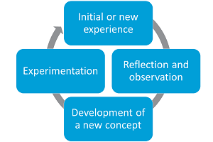
There is a clear link between action, reflection and change within this style of learning. In the activity-reflection model there are four stages to the cycle of reflection:
- The initial or new experience
- Reflection and observation
- Development of a new concept
- Experimentation.

Critical incidents

A critical incident need not be a dramatic event: usually it is an incident which has significance for you. It is often an event which made you stop and think, or one that raised questions for you. It may have made you question an aspect of your beliefs, values, attitude or behaviour. It is an incident which in some way has had a significant impact on your personal and professional learning.
In the university setting, a critical incident might include:
- an aspect of your project or group work that went particularly well
- an aspect of your project or group work that proved difficult
- a piece of work that you found particularly demanding
- a piece of work which increased your awareness, or challenged your understanding, of social justice issues; or
- an incident involving conflict, hostility, aggression or criticism (Fook & Cooper, 2003).
In the clinical setting, a critical incident might include:
- a medical emergency
- an unusual condition
- a difficult situation
- a communication problem (eg. with a patient or colleague)
- an interaction with a patient which made an impression on you (either positive or negative)
- an incident that made you feel inadequate in some way
- a time when you felt confronted; or
- an incident which made you think differently, or caused you to question your assumptions or beliefs.
Critical incidents may relate to issues of communication, knowledge, treatment, culture, relationships, emotions or beliefs.
Sample of CIA
The writing style required in producing a critical incident report is different from that of an academic essay; however, it is still important to present ideas in a systematic and organized way, and to use appropriate language. The sample below uses sub-headings consistent with the assignment requirements to explicitly organize the report. It is simply written, and avoids use of jargon or colloquial language.

Context of the incident
This report will outline a critical incident which occurred in Week 9, Semester 2 in my clinical tutorial. The incident was initiated by my tutor, who announced that she would provide individual feedback to students on their performance in clinical tutorial discussions. She also stated that she would be producing written comments on each student's behaviour, attitude and contribution in tutorials to be incorporated into student portfolios for Semester
Details of the incident
At the end of my clinical tutorial my tutor arranged for us to meet briefly in order for her to discuss her feedback with me. She stated that over the semester she had noticed that I very rarely spoke in the tutorials and did not appear to engage with the other students. She was concerned that I appeared to lack confidence, and explained that being able to express opinions clearly and confidently was essential in my future career as a doctor. In her view the only way to develop confidence was to participate regularly. She asked me how I felt about this, and if there was a reason why I almost never spoke in class. I explained that in my culture students were not always encouraged to speak, and for that reason I did not find it easy. I also mentioned that I sometimes feel shy.
Thoughts, feelings and concerns
At the time of this incident, many emotions were running through me. I felt embarrassed that my lack of confidence was so obvious to her, and also concerned about what impact it might have on my results. I was worried that she would write negative comments about my behavior and attitude, and that these comments would be available for other lecturers to read. At the same time, I realized that her concerns were justified – I had been aware of my lack of contribution throughout the semester, and had even avoided going to some tutorials because of those feelings. This was also an unfamiliar situation for me, as I had always done very well at school and achieved good marks, so I had never had to talk with a teacher in this way before. Although I understood that her intention was to help me to do better, I felt very uncomfortable and even ashamed to have to acknowledge my poor performance in this area. I felt guilty when I realized that in her opinion I had contributed so little to the class.

Demands
This incident was very demanding because it forced me to acknowledge an area where I have always lacked confidence. Even though I preferred to focus on other areas, I knew that my tutor would be noticing my behavior in tutorials over the rest of the semester, and that her written comments would depend on my performance, so as a consequence I felt under pressure. I also felt anxious about confronting this issue and trying to develop the confidence I needed.

Impact on studies
Although this incident caused me discomfort and added pressure in the short term, I realize that it was a very significant event in my studies. As a result of the conversation with my tutor I was forced to reconsider my behavior in tutorials and became more aware of how others viewed me. I had been used to think that I was 'invisible' in tutorials, but now I realized that not talking actually made me stand out more. Fortunately, the tutor gave me advice on how to gradually develop the confidence I needed, and I also sought help from some of my friends. I even organized to have some informal tutorials with friends to give me a chance to practice. Over the final weeks of the semester I managed to talk at least once in every clinical tutorial, either asking a question or making a comment. I have started trying to talk in other tutorials also, in other subjects. I have set myself the goal of talking at least once every tutorial.
This incident was therefore very important, because without it I would still be remaining silent in my tutorials, and would have received negative written comments from my clinical tutor in my portfolio. More importantly, it has helped me to acknowledge and work on an area for improvement which will be beneficial in all aspects of the course. Developing greater confidence at speaking in tutorials may lead to me being more confident in performing clinical examinations on patients. It may also lead to me feeling more in control and experiencing fewer nerves during my Objective Structured Clinical Examination (OSCE) assessments.

Impact on career
My tutor was right in stating that a doctor must be able to express opinions clearly and confidently. Good communication skills are essential for doctors, and are important in nearly all aspects of medicine. I feel that I will be more confident in dealing with patients and more effective in taking a patient history, for example. Developing greater confidence in how I communicate can lead to patients having greater trust in me as their doctor. Improving my skills in this area will also make me more effective in discussing cases with colleagues, and in participating in teams when necessary.
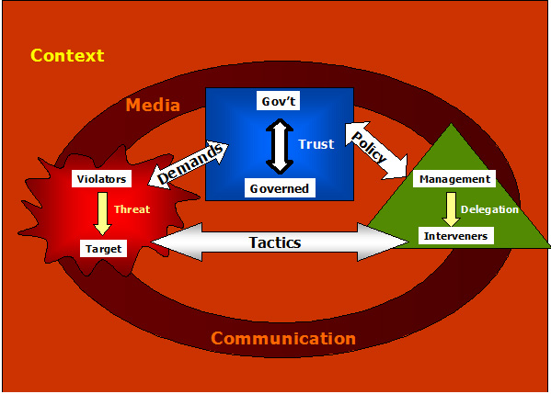
This incident made me realize that I can talk confidently once I overcome my initial fears. It demonstrated to me that in order to make progress or create positive change you must first acknowledge that a problem exists. This is a lesson which may be useful in better understanding patient behavior and attitudes. Often the first step to improving a situation, or dealing with a problem, is accepting that some change is necessary; and I may be more able to impart this information to patients having experienced this incident. Overall, this incident has had a positive impact on both my studies and the development of skills needed in my future career.


Discuss Common Teaching methods in nursing.
Lecture
- STRENGTHS:
- - presents factual material in direct, logical manner
- - contains experience which inspires
- - stimulates thinking to open discussion
- - useful for large groups

- LIMITATIONS:
- - experts are not always good teachers
- - audience is passive
- - learning is difficult to gauge
- - communication in one way

- PREPARATION:
- - needs clear introduction and summary
- - needs time and content limit to be effective
- - should include examples, anecdotes
Lecture With Discussion
- STRENGTHS:

- involves audience at least after the lecture
- audience can question, clarify & challenge

- LIMITATIONS:
- time may limit discussion period
- quality is limited to quality of questions and
- discussion

- PREPARATION:
- requires that questions be prepared prior to
- discussion Panel
Panel of Experts
- STRENGTHS:
- allows experts to present different opinions
- can provoke better discussion than a one person
- Discussion

- frequent change of speaker keeps attention from lagging
- LIMITATIONS:
- experts may not be good speakers
- personalities may overshadow content
- subject may not be in logical order
- PREPARATION:
- facilitator coordinates focus of panel, introduces and

Summarizes briefs panel

Brainstorming
- STRENGTHS:
- listening exercise that allows creative thinking for new ideas
- encourages full participation because all ideas equally recorded
- draws on group's knowledge and experience
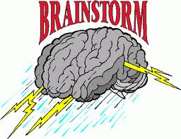
- spirit of congeniality is created
- one idea can spark off other ideas
- LIMITATIONS:
- can be unfocused
- needs to be limited to 5 - 7 minutes
- people may have difficulty getting away from known reality
- if not facilitated well, criticism and evaluation may occur
- PREPARATION:
- facilitator selects issue
- must have some ideas if group needs to be stimulated
Videotapes
- STRENGTHS:
  - entertaining way of teaching content and raising issues
  - keep group's attention
  - looks professional
  - stimulates discussion

- LIMITATIONS:
  - can raise too many issues to have a focused discussion
  - discussion may not have full participation
  - only as effective as following discussion.
- PREPARATION:
  - need to set up equipment
  - effective only if facilitator prepares questions
to discuss after the show .
Class Discussion
- STRENGTHS:
  - pools ideas and experiences from group
  - effective after a presentation, film or experience
that needs to be analyzed

  - allows everyone to participate in an active process
- LIMITATIONS:
  - not practical with more that 20 people
  - few people can dominate
  - others may not participate
  - is time consuming
  - can get off the track
- PREPARATION:
  - requires careful planning by facilitator to guide discussion
  - requires question outline.
Small Group Discussion
- STRENGTHS:
  - allows participation of everyone
  - people often more comfortable in small groups
  - can reach group consensus
- LIMITATIONS:
  - needs careful thought as to purpose of group
  - groups may get side tracked
- PREPARATION:
  - needs to prepare specific tasks or questions for group to answer

Case Studies
- STRENGTHS:
  - develops analytic and problem solving skills
  - allows for exploration of solutions for complex issues
  - allows student to apply new knowledge and skills
- LIMITATIONS:
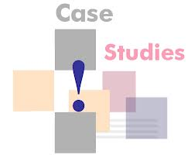
  - people may not see relevance to own situation
  - insufficient information can lead to inappropriate results
- PREPARATION:
  - case must be clearly defined in some cases
  - case study must be prepared
Role Playing
- STRENGTHS:
  - introduces problem situation dramatically

  - provides opportunity for people to assume roles of others and thus appreciate another point of view
  - allows for exploration of solutions
  - provides opportunity to practice skills
- LIMITATIONS:
  - people may be too self-conscious
  - not appropriate for large groups
  - people may feel threatened
- PREPARATION:
- Trainer has to define problem situation and roles clearly
- Trainer must give very clear instructions
Report-Back Sessions
- STRENGTHS:
  - allows for large group discussion of role plays,
  - case studies, and small group exercise
  - gives people a chance to reflect on experience
  - each group takes responsibility for its operation

- LIMITATIONS:
  - can be repetitive if each small group says the same thing
- PREPARATION:
  - trainer has to prepare questions for groups to discuss.

Worksheets/Surveys
- STRENGTHS:
  - allows people to think for themselves without
being influences by others individual thoughts can
then be shared in large group
- LIMITATIONS:
  - Can be used only for short period of time
- PREPARATION:
  - Facilitator has to prepare handouts
Describe the different management methods in nursing.
- Case Method…
The new method, traced back to Florence Nightingale, began in the early days of the nursing profession and was the convenient and appropriate way to manage care. Individuals are assigned to give total care to each patient, including the necessary medicine and treatments. The nurses report to their immediate superior, who is the head nurse. The disadvantages of this system are that all personnel might not have been qualified to deliver all aspects of care, and depending on the structure, too many people were reporting to the head nurse (overextended span of control).
- Functional Method
The functional method is the next step to deal with different levels of caregivers. Assignments of patient care are made by the level of task; in other words, each person performs one task or functions in keeping with the employees’ educational experience.
For example

Nurse Aides /Health Assistants/ give baths, feed patients, and take vital signs to all patients. Professional nurses are responsible for medications,
treatments, and procedures for all patients.
The head nurse is responsible for overall direction,
supervision, and education of the nursing staff.

- Advantages

  - Reduce personnel costs
  - Supports cost control
- Disadvantages
  - Fragments nursing care
  - May decrease staff job satisfaction
  - Decreases personal contacts with client
  - Limits continuity of care.
- Team Nursing

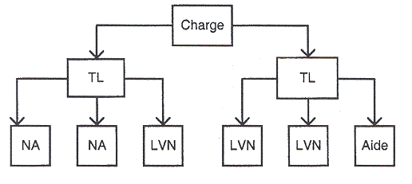
A dramatic change occurred after World War II in the years between 1943 and 1945. The level and number of auxiliary personnel began increasing, and the professional nurse was assuming more and more of the management functions. Because of the changing configuration of the work group and the dramatic social upheaval, a study was commissioned to device a better way to provide nursing care. Dr. Eleanor Lambert son of Columbia University in New York and Francis Perkins of Massachusetts General Hospital were the authors of the system known as team nursing. Team nursing was developed to deal with the influx of post war workers and the head nurse’s overextended span of control. This was accomplished by arranging the workers in teams. The team consists of the senior professional nurse becoming the team leader; the members of the team are other registered nurses (RNs), licensed practical nurses (LPNs) or vocational nurses, and nurses’ aides. Each is being given a patient assignment in keeping with the employee’s education and experience. The team leader make the assignments, delegated the work through the morning report, make rounds throughout the shift to make sure patients are being cared for properly, and conducts a team conference at the end of the shift to evaluate the patient care and plan an update nursing care plans. Since 1950, team nursing is becoming a popular way to structure nursing care.
Positive Reinforcement
Employees are expected to come to work and perform the tasks and duties associated with their job description. When people go above and beyond these expectations or demonstrate a behavior that epitomizes him or her as a role model a method should be in place for ensuring this behavior persists. Positive reinforcement both publicly and individually will assist in reinforcing positive behavior. Aubrey Daniels believes that behavior that isn’t reinforced will die out (Johnson, 2006). Desired behaviors should be acknowledged by managers soon after they are exhibited to reinforce the positive behavior. Public praise, delegating new tasks or responsibilities, a written thank- you and the responsibility to mentor or precept another employee are methods of positive reinforcement.
Energize
The manager needs to have the ability to energize the workers by reviewing the goals of the organization and creating visions for the employees. Empower the staff by delegating responsibility and extending the authority needed to achieve the goal. It is extremely important to support the staff or coach and mentor them in their professional growth. Bob Nelson, founder of Nelson Motivation Inc, recognizes the initiative that managers need to create supportive workplaces which may influence desired behaviors and end results (Nelson, 2006).
Motivating Employees

Jennifer Wilson, owner of Convergence Coaching LLC, identifies six motivators which consist of
1) Acknowledgement and Respect,
2) Camaraderie and Fun,
3) Compensation,
4) Flexibility and Time Off
5) Increased Responsibility and Challenge And
6) Personal and professional growth (Wilson, 2006).
She explains that it is necessary to have each person divulge
what motivates them as an individual in relation to the six
motivators and place them in specific order from highest to lowest.
Discussing the motivators in a group setting and on an individual basis,
will allow the Manager to better understand the emphasis placed upon
each motivator.

Constructive Conversations
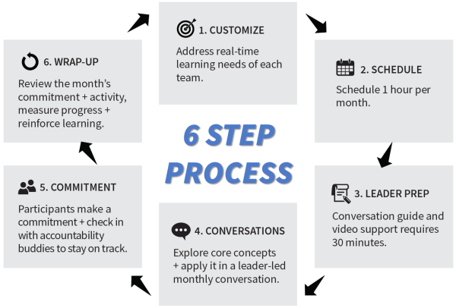
These particular conversations are able to improve low morale, turnover rate and low productivity along with stress and loss of compassion. Nurses are known for embracing the concept of compassion and when that is lost, the art of caring for others is severely affected. A manager who consistently delivers a constructive interaction will have an impact on the staff, and the outcome should be a more engaged, happier crew. This mode of exchange will also set an example for the staff and being the recipient of a constructive exchange they can experience the difference and be aware of utilizing a positive exchange on a peer. The accepted norm could progress towards the lack of acceptance of inferior modes of behavior if the benefits of constructive conversations were experienced by the staff. Julie Fuimano, a writer, motivational speaker and professional coach, stresses the importance of constructive conversations and the idea that they are significant, affirmative and favorable and upon completion leaves those involved feeling upbeat. She offers the idea that to partake in a dialogue involves thinking about the purpose of it and making it a positive interaction (Fuimano, 2006).

Timed-task/Activity Method
This method of estimating or evaluating the size and mix of nursing teams arose from a belief that acuity-quality staffing methods, for example, were inferior staffing predictors. The type and frequency of nursing interventions required by patients, on the other hand, are felt to be a better guide because the number of patient variables impinging on nursing time is more fully considered. If nurses are comfortable with constructing care plans for their patients then the timed-task/activity method simply adds nursing minutes to each intervention there by generating the number of nursing hours needed. This method will suit wards in which care plans are systematically constructed, and for wards where patients’ nursing needs can beconfidently predicted; notably wards that admit from waiting lists.

